# Coloma Convent Girls’



Secondary School & Sixth Form

**Deputy Headteacher**

Candidate Information Pack



**Tel**: (0208) 654 6228

**Email**: [office@coloma.croydon.sch.uk](mailto:office@coloma.croydon.sch.uk)

Welcome

## Welcome from our Headteacher

Dear Candidate,

Welcome to Coloma Convent Girls’ School & Sixth Form. Thank you for your interest in the role of Deputy Headteacher in our successful, vibrant and ambitious community.

In August 1969, Coloma first opened its doors in Croydon and for 60 years has stood in the foothills of Shirley as a place of faith, learning and opportunity. Our beautiful grounds frame a deep history, one that has shaped generations of young women who leave us equipped to make a difference in the wider world.

We are guided by our Catholic ethos; the love of God, Gospel values, service, faith and compassion and believe in educating the whole person. Our mission is clear: to nurture the pursuit of our God given greatness today in the leaders of tomorrow. At Coloma, that includes setting the highest standards for both staff and students; expecting integrity, discipline, self‑belief and a love of learning in every classroom; fostering courage, compassion and wisdom in every decision; and always being guided by God in our purpose.

We are looking for someone who is committed to working with colleagues across our Trust and who is committed and ambitious for their own professional development. We serve the families of the local community and are part of St Oscar Romero Catholic Academy Trust, an established multi-academy trust of four secondary and twelve primary schools in South East London and Kent.

In practical terms: we offer a contemporary, broad and challenging curriculum from Key Stage 3 through to Sixth Form. We value support, stretch and challenge, academic rigour, and offering every pupil access to doors that open for higher education, future careers and leadership in any area of the globe. Because we are a school for girls and young women, empowering them is not an add‑on but central to our work. We believe that giving girls confidence and ambition, rooted in strong moral values, changes lives.

We expect our staff to share our commitment to excellence: professionals who will maintain high expectations, inspire, support and challenge; who will contribute to our Catholic life and lead with compassion, courage and integrity.

As Deputy Headteacher, you will join a community that is both proud of its history and excited for its future. You will help to sustain a school culture where every girl knows she is loved, valued and cared for; where faith, kindness and service are lived; where success is achieved not at the expense of others but through hard work, respect and caring for all.

If you believe, as we do, that greatness is possible in every young woman here, that education is more than academic results but the formation of character, and that faith and learning belong together, then Coloma could be the place for you.

I look forward to exploring your vision for how you would help lead Coloma forward on our journey towards exceptional education for all.

With warm regards,

Mrs D Bumford Sinclair

**HEADTEACHER**

Coloma Convent Girls’ School

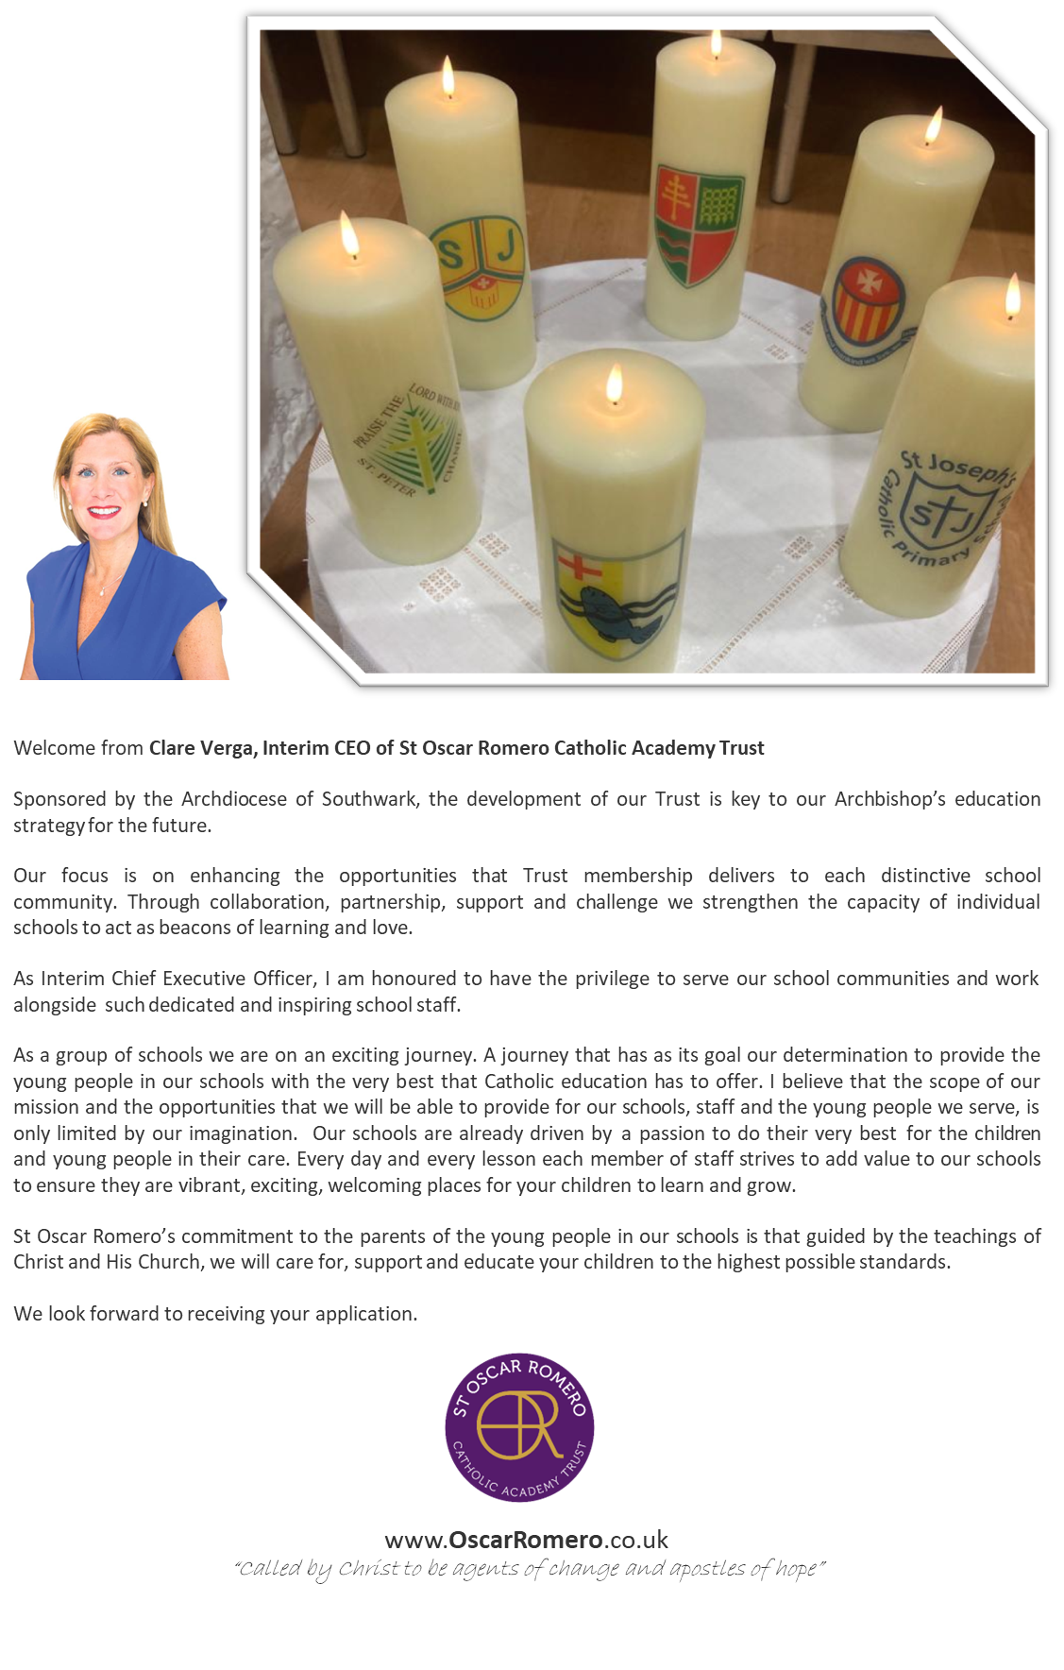

Recruitment process

## 

## Recruitment Process:

Once you have submitted your application, it will be assessed against the criteria in the person specification. Successful candidates will then be invited to attend an interview.

## Special Requirements:

If you require reasonable adjustments prior to your interview, these can be arranged by contacting the school.

## Equality and Diversity:

We recognise the benefits of a diverse workforce. We are committed to eradicating discrimination in the workplace, becoming an employer of choice, for all staff to believe that they have a voice and be empowered to make a difference.

**References**: Before you are invited to interview, we will obtain references from your referees. In order to prevent any delays, please ensure that the reference section of the application form is accurate and completed in full.

**Right to work in the UK**: Section 8 of the Asylum and Immigration Act 2006 makes it a criminal offence for an employer to take on a new employee whose immigration status prevents him/her from taking up employment. If you are invited to attend an interview, you will be asked to produce original and up to date documentary evidence of your right to work in the UK.

**Criminal Convictions**: All education establishments in the UK are exempt from the Rehabilitation of Offenders Act 1974. In practice, this means that all applicants must inform on all spent and unspent convictions on their application form and when completing a Disclosure and Barring form. Failure to provide this information may result in dismissal. A Children’s Barred List check is also obtained on anyone who will be working or coming into contact with children; and must be received by the School before employment can commence.

**Data Protection**: Any data about you will be held securely with access restricted to those involved in dealing with your application in the selection process. By signing and submitting your application form, you are giving consent to the processing of your data.



An exciting opportunity has arisen for an exceptional candidate to become Deputy Headteacher of Coloma Convent Girls’ School. We are seeking a Deputy Headteacher who is a practising Catholic in full sacramental communion*, ambitious and dynamic; someone who has the passion to ensure that the school is consistently up to date with contemporary practices and matches our drive to ensure the school provides the best for all students in every area.



**Job Title:** Deputy Headteacher

**Contract Length**: Full Time and Permanent

**Salary Range**: Leadership Scale 22-26 (*Dependent on skills and experience)*

**Accountable to**: Headteacher

**Coloma Convent Girls’ School**

Job advertisement

The Deputy Headteacher will be an inspirational leader who can bring vision, energy and a proven track record of excellent leadership. The specific responsibilities will be shaped around the strengths of the successful candidate and the needs of the Leadership Team. However, we are particularly interested in candidates with significant experience of leading change within pastoral and safeguarding teams, and who can ensure that the wellbeing, inclusion and safety of our young people remain at the forefront of our school and sixth form. The successful candidate will be supported to gain experience of leadership across a full range of school improvement opportunities, and they will not be limited to only one area of school life. This will enable them to develop as a confident, versatile and well-rounded senior leader with the capability to deliver at the highest levels of school leadership with Christ at the Centre.

The Coloma experience is so much more than a comprehensive education. For over 150 years we have been driven to challenge our pupils to become successful young women who display compassion and courage both within the school community and beyond. The successful candidate will be committed to establishing a positive and proactive culture that promotes excellence, focusing on collaboration and driving internal excellence, underpinned by Gospel Values.

Being a Deputy Headteacher within the St Oscar Romero Catholic Academy Trust provides

opportunities to work collaboratively with other Deputy Headteachers and School Leaders

therefore having opportunities to shape the educational landscape across South East London.

The ideal candidate will:

* be a practising Catholic in full sacramental communion;
* have extensive previous experience of working as part of a Senior Leadership Team;
* have experience of leading pastoral and safeguarding teams;
* be able to demonstrate success at leading school improvement and raising educational standards for children;
* possess the ability to empower staff and include them in the next stages of the school’s journey;
* be an excellent written and verbal communicator;
* align to the mission, vision and values of Coloma Convent Girls’ School and Sixth Form, St Oscar Romero Catholic Academy Trust and the Archdiocese of Southwark.



**Closing date:**

15th October 2025@ 10am

**Interview date:**

w/c 20th October 2025

**Start date:**

January 2026/ Easter 2026

In return we offer:

* opportunities to work within a highly skilled and

supportive team;

* a commitment to continue with national pay,

terms and conditions;

* access to the generous Teachers Pension Scheme;
* a highly supportive working environment;
* training opportunities to support a continuing

leadership journey.

Visits to our beautiful school site in the Shirley Hills are highly encouraged. To arrange an informal conversation with the Headteacher and/or to arrange a tour then please contact Mrs Vicki Davis, Executive Assistant to the Headteacher, via [**vdavis@coloma.co.uk**](mailto:vdavis@coloma.co.uk)

**Further details of this role can be found on TES,** [Coloma website](http://www.coloma.co.uk/) and [RCAOS website](https://www.rcsouthwark.co.uk/get-involved/vacancies/)

**\*A ‘practicing Catholic’ is defined as someone who has been sacramentally initiated in to the Catholic**

**Church and who adheres to those substantive life choices which do not impair them from receiving**

**the sacraments of the Church and which will not be in any way detrimental or prejudicial to the**

**religious ethos and character of the school. Inspired by the Gospel and sustained in God’s grace, a**

**practicing Catholic will give sincere external expression to their interior faith through specific religious,**

**moral and ethical behavior which is in accordance with the teaching of Christ and the Catholic Church**

About the role

**Job Overview**

The Deputy Headteacher is a member of the Senior Leadership Team (SLT) responsible for contributing to the management and leadership of the school and the day-to-day education, wellbeing, child protection, safeguarding and pastoral care of students and staff at Coloma.

The Deputy Headteacher is responsible for the line management of staff including other Senior Leaders, Middle leaders and Support Staff.

**Key Responsibilities**

The Deputy Headteacher, alongside or under the direction of the headteacher, will take a major role in:

* Formulating the aims and objectives of the school including those pertaining to Catholic Life, Mission and Ethos;
* Promoting a culture which prioritises safeguarding and wellbeing;
* Establishing policies for achieving these aims and objectives;
* Managing staff and resources to that end;
* Monitoring progress towards the achievement of the school’s aims and objectives;
* Championing the school’s ongoing work on Equality, Diversity and Inclusion amongst staff and students;
* Ensuring that statutory obligations are met

If the Headteacher is absent, the Deputy Headteacher will deputise, as directed by the local governing committee. The Deputy Headteacher will also be expected to fulfil the professional responsibilities of a headteacher, as set out in the School Teachers’ Pay and Conditions Document (STPCD).

**Qualities**

The Deputy Headteacher will:

* Promote the Gospel Values by their personal example therefore, the post of Deputy Headteacher be filled by a practicing Catholic* who can show, by example and from experience, that he or she will ensure that the school is distinctively Catholic in all aspects with Christ at Centre.
* Uphold public trust in school leadership and maintain high standards of ethics,
* behaviour and professional conduct
* Build positive and respectful relationships across the school community
* Serve in the best interests of the school’s pupils

**\*A ‘practicing Catholic’ is defined as someone who has been sacramentally initiated in to the Catholic Church and who adheres to those substantive life choices which do not impair them from receiving the sacraments of the Church and which will not be in any way detrimental or prejudicial to the religious ethos and character of the school. Inspired by the Gospel and sustained in God’s grace, a practicing Catholic will give sincere external expression to their interior faith through specific religious, moral and ethical behavior which is in accordance with the teaching of Christ and the Catholic Church.**

**Duties and responsibilities**

The duties and responsibilities of the Deputy Headteacher are aligned to the Headteachers’ Standards (2020) as set out by the Department for Education.

**School culture and behaviour**

Under the direction of the Headteacher, the Deputy Headteacher will:

* Promote and prioritise the safeguarding of all pupils;
* Act as the school’s Deputy DSL deputising for the DSL in their absence;
* Work alongside the senior leadership team (SLT) and other staff members to create a culture where pupils experience a positive and enriching school life;
* Uphold educational standards in order to prepare all pupils for their next phase of education and life regardless of their starting points;
* Ensure a culture of staff professionalism and accountability;
* Encourage high standards of behaviour from pupils, built on rules and routines that are understood by staff and pupils, and clearly demonstrated by all adults in school;
* Use consistent and fair approaches to managing behaviour, in line with the school’s
* behaviour policy



**Teaching, curriculum and assessment**

About the role cont.

Under the direction of the headteacher, the Deputy Headteacher will:

* Establish and sustain high-quality teaching across all subjects and phases, based on evidence;
* Ensure teaching is underpinned by subject expertise;
* Commit to an inclusive “education for all and of all” approach so that all pupils achieve well;
* Effectively use formative assessment to inform strategy and decisions;
* Ensure the teaching of a broad, structured and coherent curriculum;
* Establish curriculum leadership, including subject leaders with relevant expertise and access to professional networks and communities;
* Use valid, reliable and proportionate approaches to assessing pupils’ knowledge and understanding of the curriculum

**Additional and special educational needs (SEN) and disabilities**

The Deputy Headteacher will:

* Under the direction of the headteacher, the Deputy Headteacher will:
* Promote a culture and practices that enables all pupils to access the curriculum;
* Have ambitious expectations for all pupils with SEN and disabilities;
* Make sure the school works effectively with parents, carers and professionals to identify additional needs and provide support and adaptation where appropriate;
* Make sure the school fulfils statutory duties regarding the [SEND code of practice](https://www.gov.uk/government/publications/send-code-of-practice-0-to-25).

**Organisational management and school improvement**

Under the direction of the headteacher, the Deputy Headteacher will:

* Establish and sustain the school’s Catholic ethos and strategic direction together with the governing board and through consultation with the school community;
* Establish and oversee systems, processes and policies so the school can operate effectively;
* Ensure staff and pupils’ safety and welfare through effective approaches to safeguarding, as part of duty of care;
* Manage staff with due attention to workload;
* Ensure rigorous approaches to identifying, managing and mitigating risk;
* Allocate financial resources appropriately, efficiently and effectively;
* Identify problems and barriers to school effectiveness, and develop strategies for school improvement that are realistic, timely and suited to the school’s context;
* Make sure these school improvement strategies are effectively implemented

**Professional development**

Under the direction of the headteacher, the Deputy Headteacher will:

* Ensure staff have access to appropriate, high standard professional development opportunities;
* Keep up to date with developments in education;
* Seek training and continuing professional development to meet needs

**Governance, accountability and working in partnership**

Under the direction of the headteacher, the Deputy Headteacher will:

* + - Understand and welcome the role of effective governance, including accepting responsibility;
    - Ensure that staff understand their professional responsibilities and are held to account;
    - Ensure the school effectively and efficiently operates within the required regulatory frameworks and meets all statutory duties;
    - Work successfully with other schools and organisations within the Diocese, Trust and LA;
    - Maintain working relationships with fellow professionals and colleagues to improve educational outcomes for all pupils

*Please note that this is illustrative of the general nature and level of responsibility of the role. It is not a comprehensive list of all tasks that the Deputy Headteacher will carry out. The postholder may be required to do other duties appropriate to the level of the role.*

**Education and Training**

Person Specification

* Qualified teacher status (QTS)
* Degree
* Catholic Certificate of Religious Studies (CCRS) – Desirable

## Experience

* Successful leadership and management experience in a secondary school
* Teaching experience
* Involvement in school self-evaluation and development planning
* Demonstrable experience of successful line management and staff development
* Leadership in pastoral care including safeguarding

## Knowledge and Skills

* Data analysis skills, and the ability to use data to set targets and identify weaknesses
* Understanding of high-quality teaching, and the ability to model this for others and support others to improve
* Understanding of school finances and financial management
* Effective communication and interpersonal skills
* Ability to communicate a vision and inspire others
* Ability to build effective working relationships

## Personal qualities

* Practicing Catholic* in full sacramental communion
* A commitment to getting the best outcomes for all pupils and promoting the ethos and values of the school
* Ability to work under pressure and prioritise effectively
* Problem-solving abilities
* Commitment to maintaining confidentiality at all times
* Commitment to safeguarding and equality, ensuring that personal beliefs are not expressed in ways that exploit the position

|  |  |  |
| --- | --- | --- |
| Personal Qualities | **Measured by:**  **A - Application** **I - Interview** | **Essential or Desirable** |
| Practising Catholic* in full sacramental communion | A | E |
| Awarded with Catholic Certificate of Religious Studies (CCRS) | A | D |
| Ability and willingness to support the Catholic ethos of the school | A, I | E |
| Commitment to a broad and balanced education for all students | A, I | E |
| People orientated leader who can inspire commitment, enthusiasm and collegiality from staff, students, parents/carers, governors and the community | A, I | E |
| Values diversity and the unique contribution every individual makes to the learning community | A, I | E |
| Highest professional standards and expectations | A, I | E |
| Able to employ a range of leadership and management styles appropriately, to motivate others | A, I | E |
| Team player | I | E |
| Approachable with a good sense of humour | I | E |
| Willingness to contribute to the wider life of the School and community | I | E |

**\*A practicing Catholic’ is defined as someone who has been sacramentally initiated in to the Catholic**

**Church and who adheres to those substantive life choices which do not impair them from receiving**

**the sacraments of the Church and which will not be in any way detrimental or prejudicial to the**

**religious ethos and character of the school. Inspired by the Gospel and sustained in God’s grace, a**

**practicing Catholic will give sincere external expression to their interior faith through specific religious,**

**moral and ethical behavior which is in accordance with the teaching of Christ and the Catholic Church**

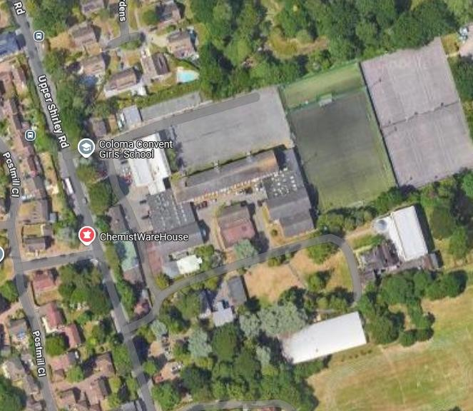

**Coloma Convent Girls’ School Upper Shirley Road**

**Croydon CR9 5AS**



**Tel: (0208) 654 6228**

“*Education is a very practical and simple thing,*

*which requires little theory, but much care;*

*few precepts but a lot of love.”*

Canon Constant William van Crombrugghe,

Founder of the Daughters of Mary

and Joseph